Slide screen installation procedure

Preparations by the buyer.
- Step 1：
Before installing the sliding screen, nail a 3 cm thick wooden board to the blank wall with a weight-bearing capacity of approximately 300 pounds. If the wall is not solid, welding a steel structure is necessary to attach the 3 cm wooden board onto it.

Example map
- Step 2：Reserve the power cable and network cable.
After installing the wooden board, set up two 3-hole power sockets at the lower left corner, 30 cm above the ground (with a 2.5 square mm power wire). Pre-embed the network cable at the socket location.

Installation process
- Step 1：
First, mount the main lower track horizontally onto the wooden board using self-tapping screws for wood. Then install the upper track, screen hanger, motor, and other auxiliary materials for the sliding screen.
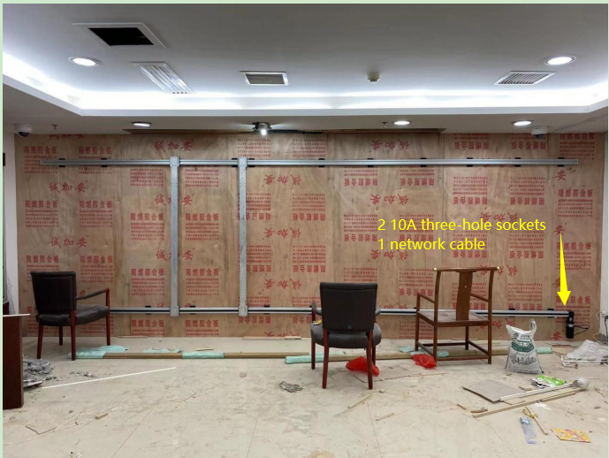 Example Map

- Step 2:
Install the screen.Organizing the cables generally involves two lines: one power cable and one network cable. We will prepare them and run them through the cable chain. After organizing the cables, first test if the sliding screen can move left and right.
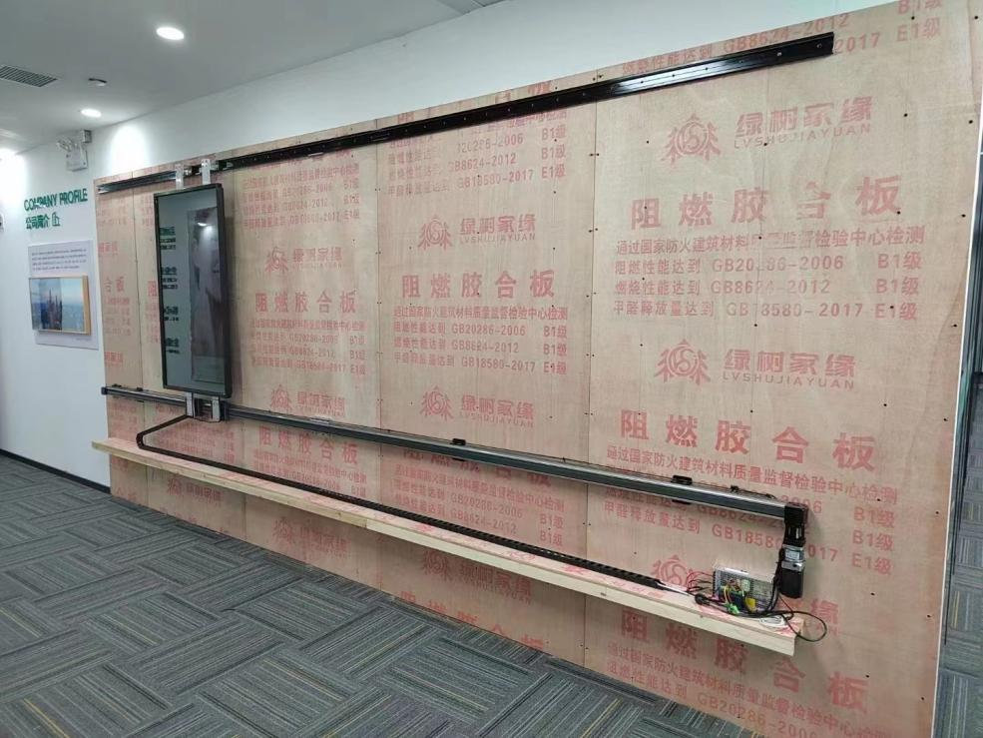
Example map
- Step 3：
Once everything is working properly, you can seal the panel. Create a 40*40 cm inspection opening at the motor location. See the diagram:
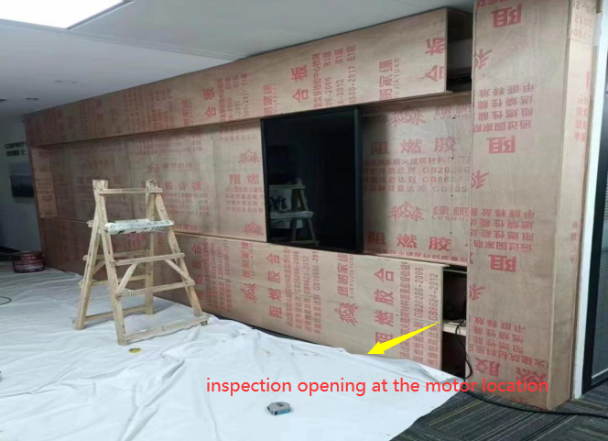

- Step 4:
Debug software, set content.
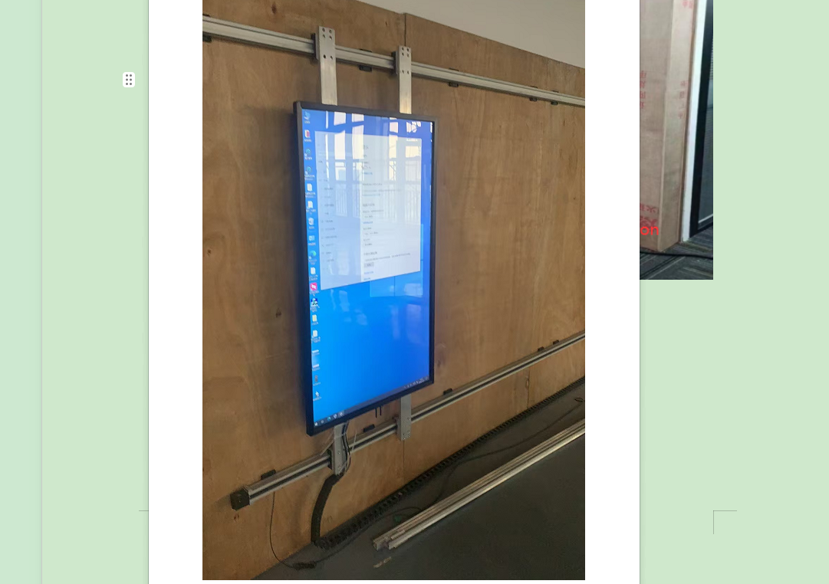
Example map

